**Be Practical Tech Solutions**

**Bangalore**



**AWS Cloud Computing Project Report(VPC)**

**Submitted By:**

**Shwetha M N**

**Trainer:**

**Hemanth Gowda**

**Project2:**

**VPC (Virtual Private Cloud)**

A VPC allows you to create a logically isolated network where you can define IP address ranges, subnets, route tables, and security settings

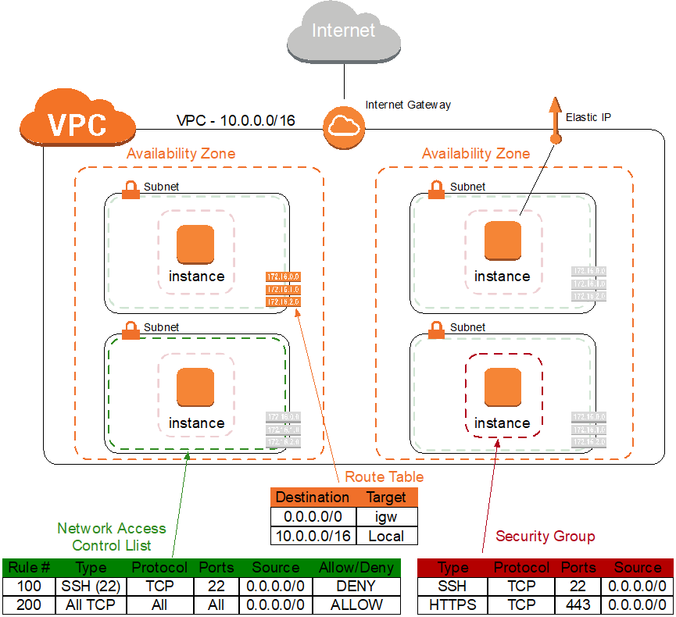

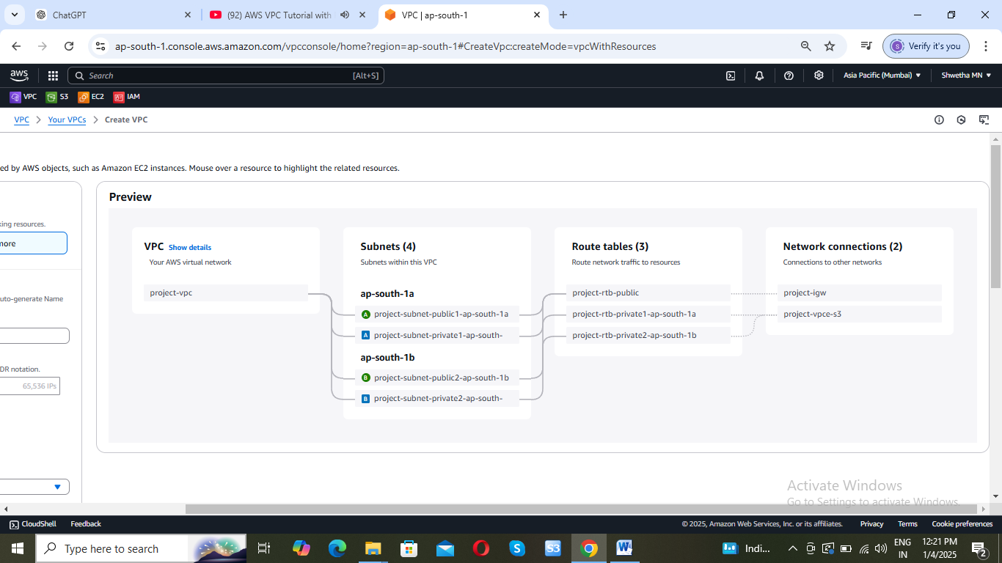

**IPV4: 32-bits address**

8bit – 00000000 to 11111111

0 to 1

* + 1. to 255.255.255.255

Ex: 192.168.0.1

11000000.10101000.00000000.00000001

**CIDR: Classless Inter Domain Routing**

VPC: 192.168.0.0/24 IPV4: 32 bit address

Network Portion: 24

Host Portion: 32-24=8 2^8=256

192.168.0.0 to 192.168.0.255

Here you will get 256 host IP address

Break VPC into 2 subnets:

**Subnet 1 (128)**

192.168.0.0/25

Network Portion: 25

Host Portion: 32-25=7 2^7=128

192.168.0.0 to 192.168.0.127

**Subnet2 (128)**

192.168.0.0/25

Network Portion: 25

Host Portion: 32-25-7 2^7=128

192.168.0.127 to 192.168.0.255

Amazon reserves the first four (4) IP address and the last one(1) IP address of every subnet for IP networking purpose.

128-5=123 🡪 So you will get 123 IP address

**Note:**

**VPCs per Region -5**

**Subnets per VPC -200**

**IPv4 CIDR blocks per VPC -5**

**Prerequisites:**

1. **AWS Account**: Ensure you have an AWS account. If not, sign up at [**AWS**](https://aws.amazon.com/)**.**
2. **AWS CLI or Management Console**: You can perform these steps using the AWS Management Console or AWS CLI.
3. Creating a VPC (Virtual Private Cloud) in AWS is an essential step for setting up your network architecture in the cloud. A VPC allows you to create a logically isolated network where you can define IP address ranges, subnets, route tables, and security settings. Here's how to create a VPC in AWS step by step:

### Step 1: Log in to AWS Management Console

* + Navigate to [AWS Management Console](https://aws.amazon.com/console/).

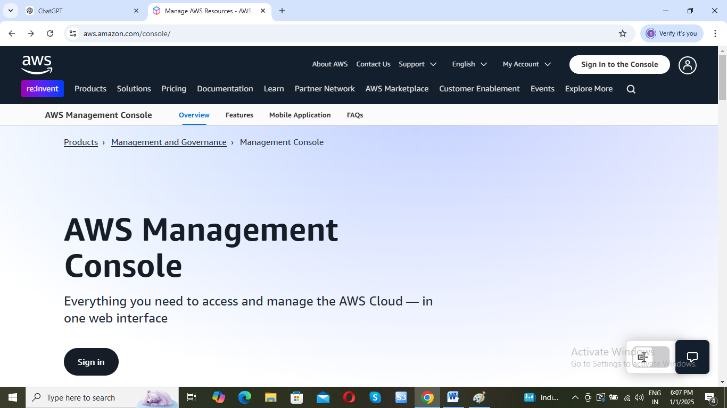

* Sign in with your AWS credentials.

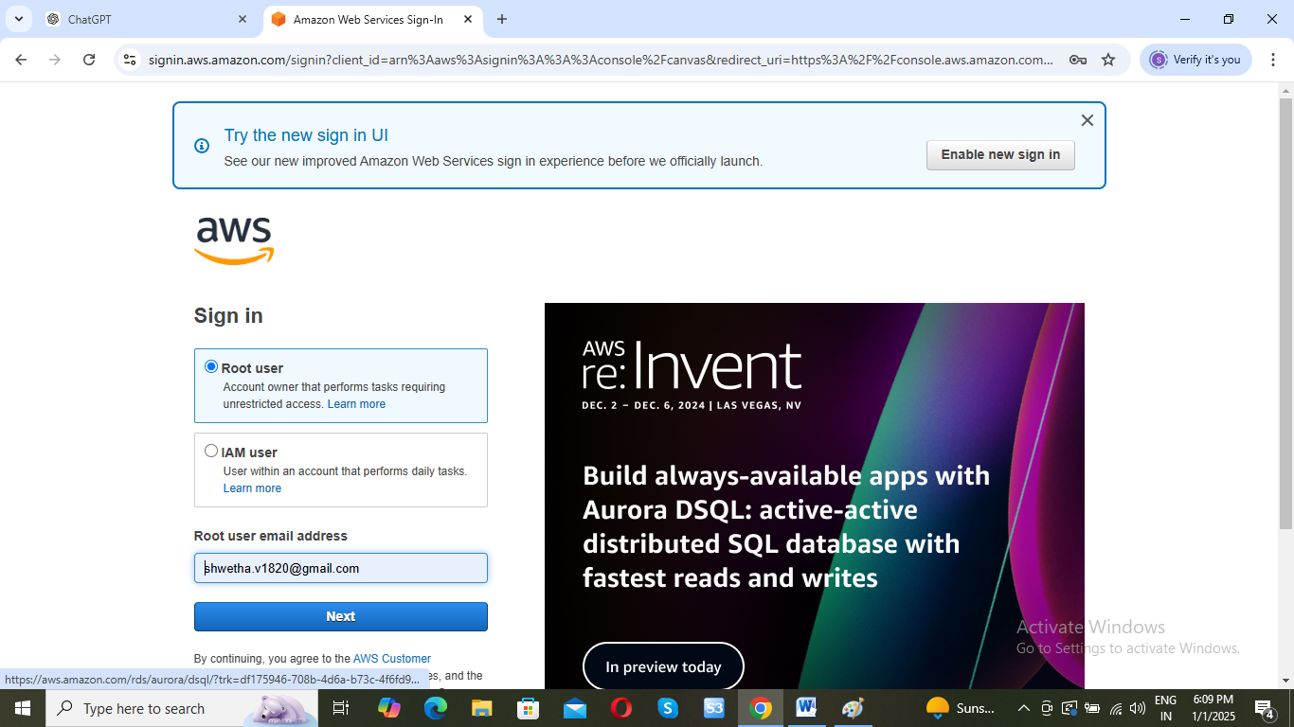

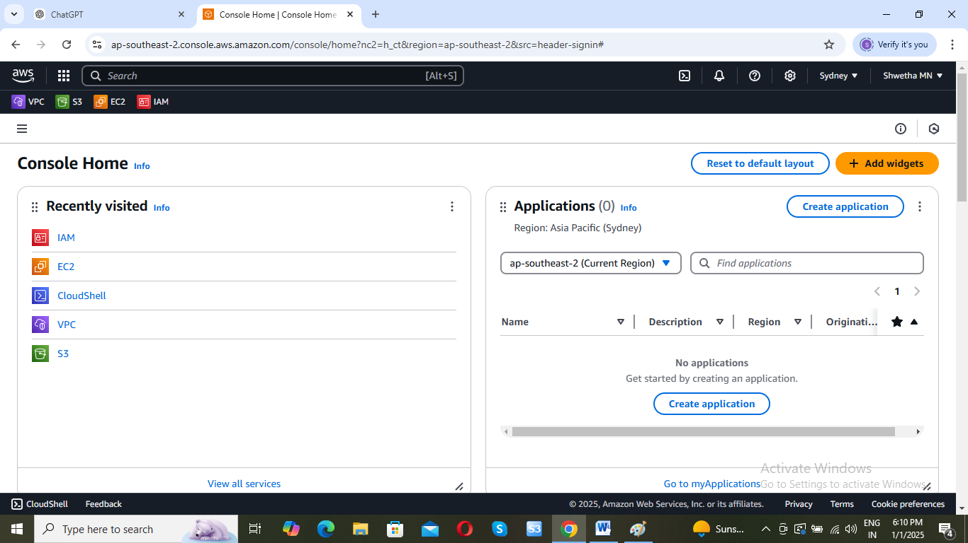

**Step 2: Navigate to the VPC Dashboard**

* In the AWS Management Console, search for **VPC** in the search bar or find it under the **Networking & Content Delivery** section.

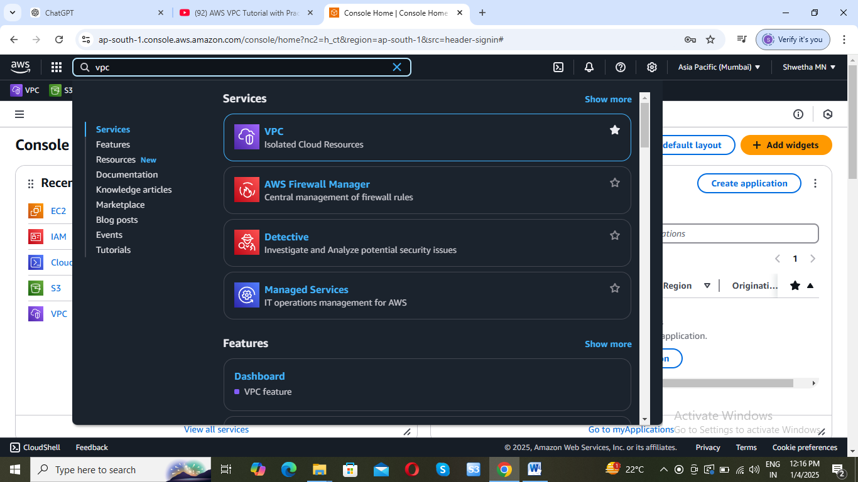

* Click on **VPC** to go to the VPC dashboard.

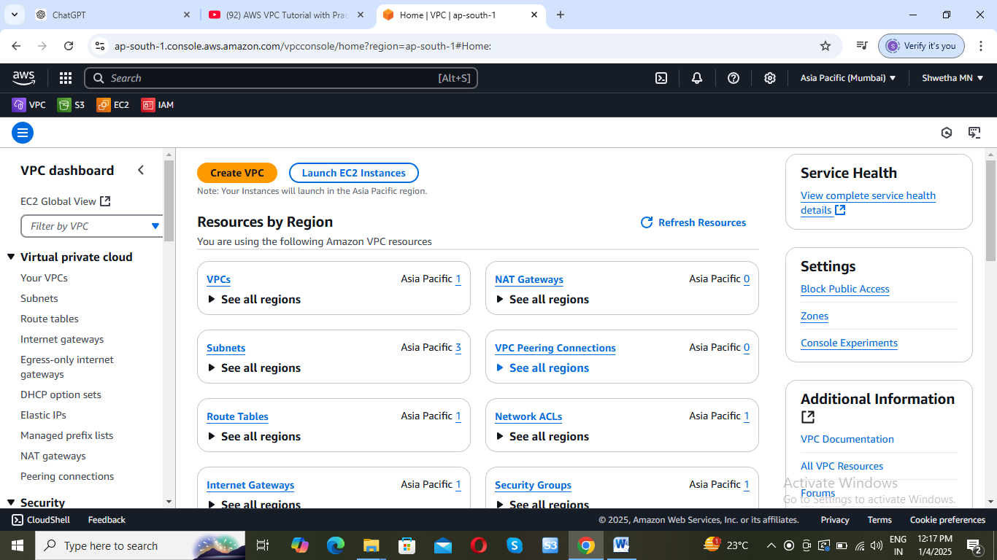

**Step 3: Create a VPC**

* In the left sidebar, click **Create VPC**.

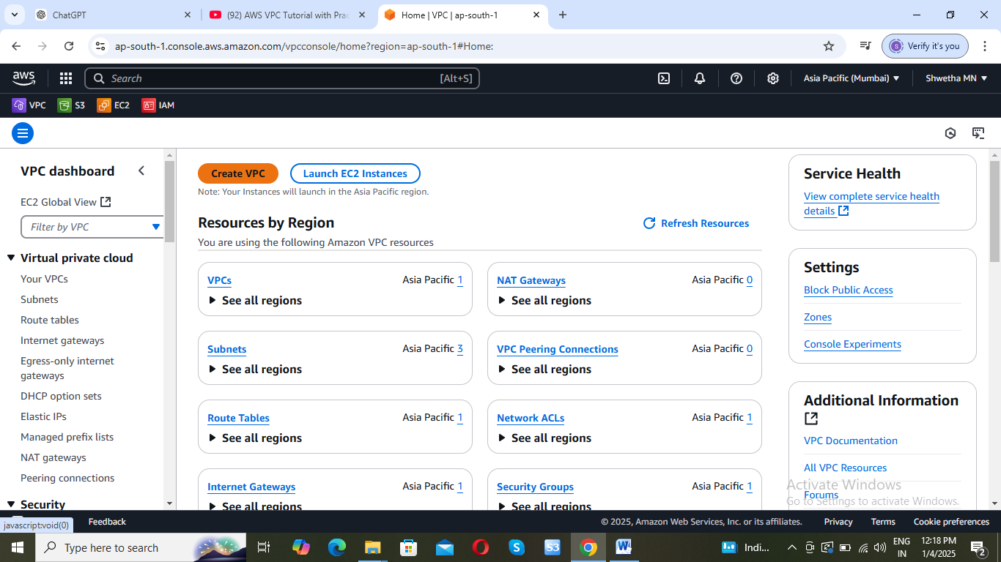

* Choose a **VPC wizard** (for simplicity, you can use the "VPC with a Single Public Subnet" option to start):

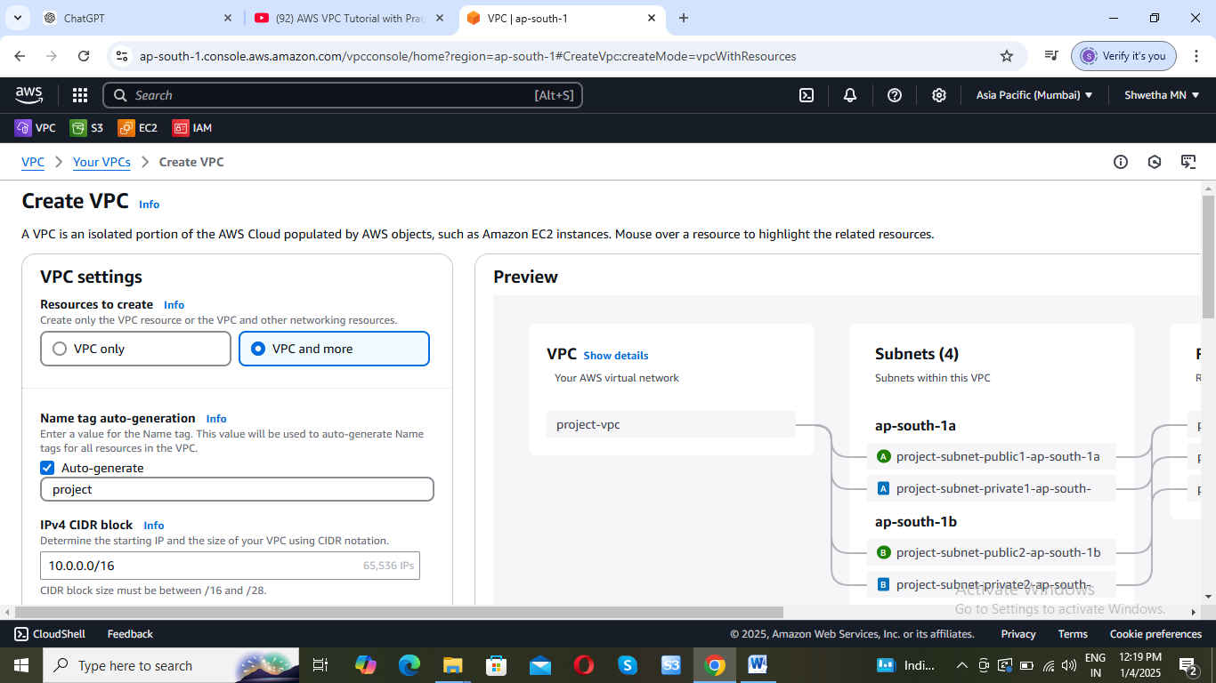

* **VPC Settings**:

**1. Name**: Give your VPC a name (e.g., my-vpc).

**2. IPv4 CIDR block**: Enter the IP range you want for your VPC, e.g., 192.168.0.0/24. This will allow you to have 255 IP addresses.

**3. Tenancy**: Choose between **Default** or **Dedicated**. "Default" means your instances will share hardware, while "Dedicated" means each instance gets isolated hardware.

4. Click **Create VPC**.

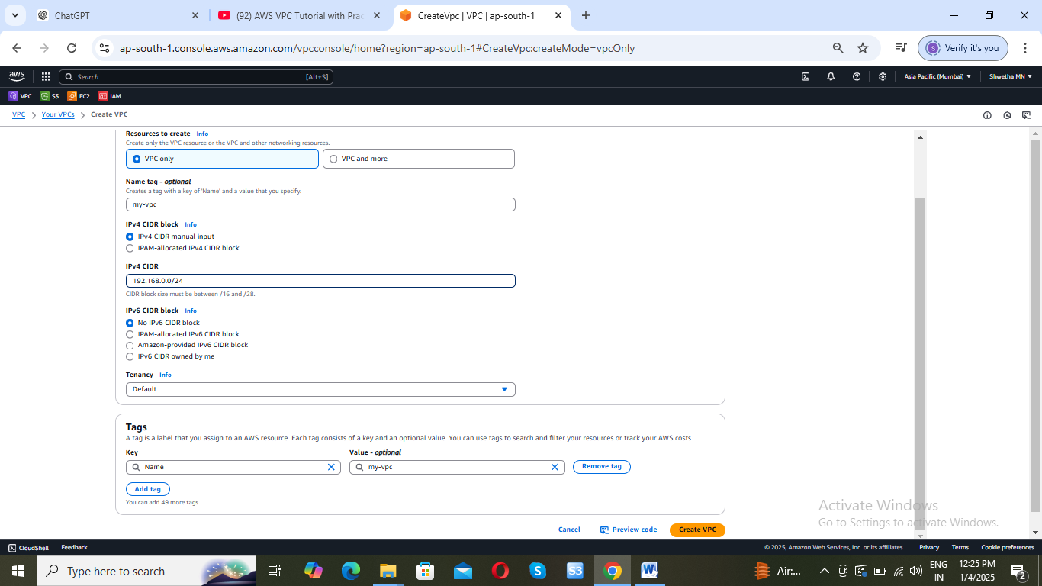

**Step 4: Create an Internet Gateway**

If you want your VPC to have access to the internet, you need to create an **Internet Gateway** and attach it to your VPC:

1. In the left sidebar, click **Internet Gateways**.

2. Click **Create internet gateway**.

3. Give it a name and click **Create**.

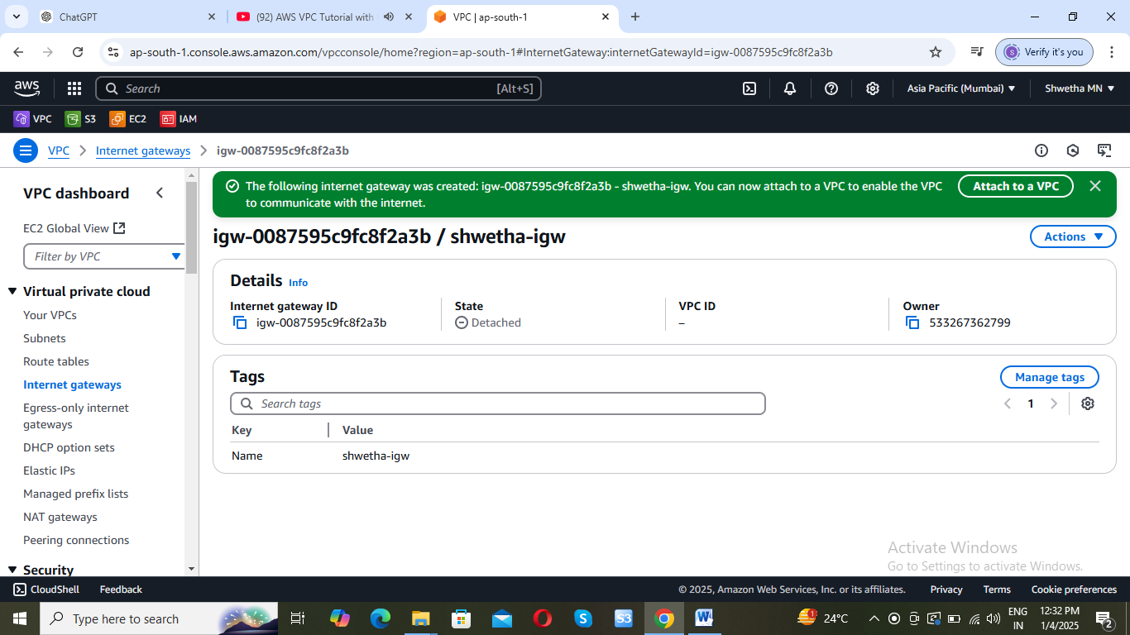

4. After creating it, click on the **Actions** button, then **Attach to VPC**.

5. Select your VPC and click **Attach**.

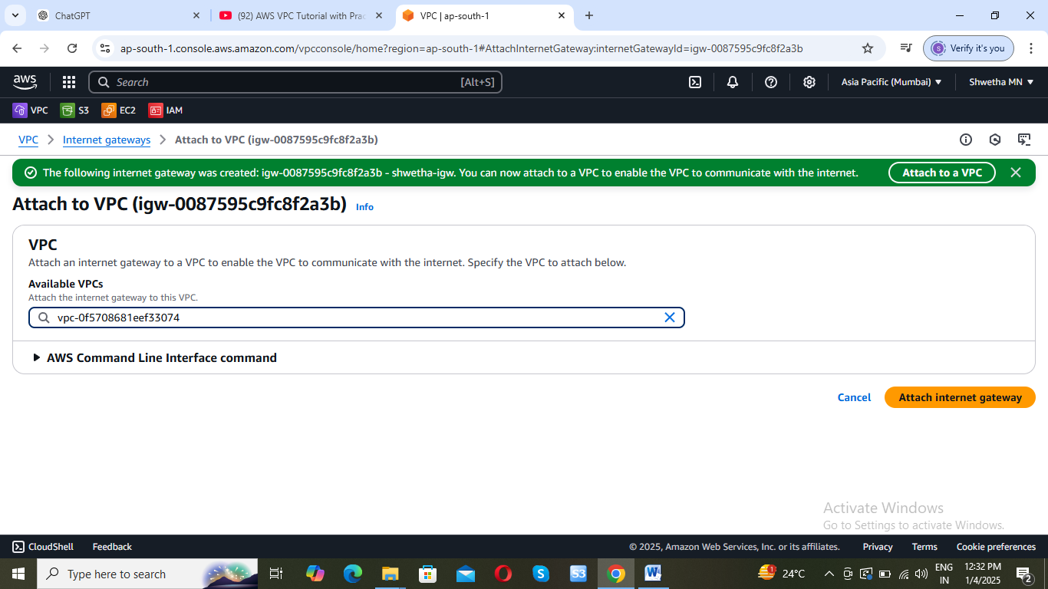

**Step 5: Create Subnets**

* After your VPC is created, you need to create **subnets**.
  1. In the left sidebar, click **Subnets**.

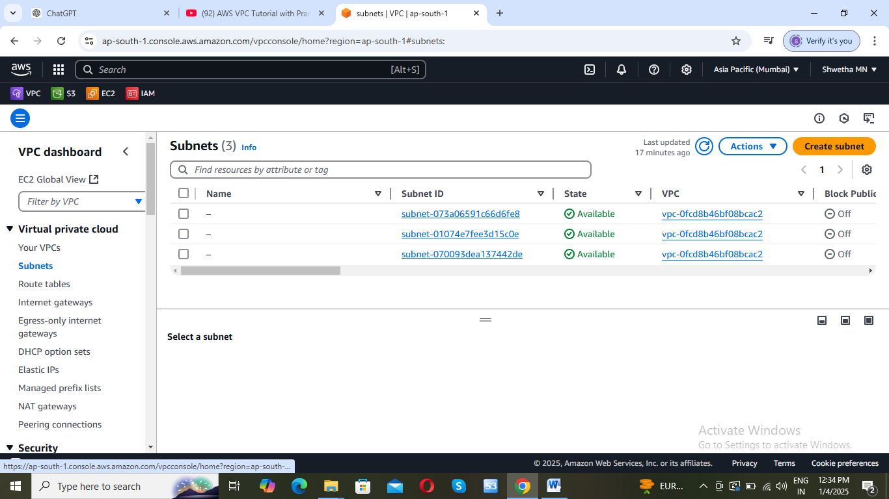

* 1. Click **Create subnet**.

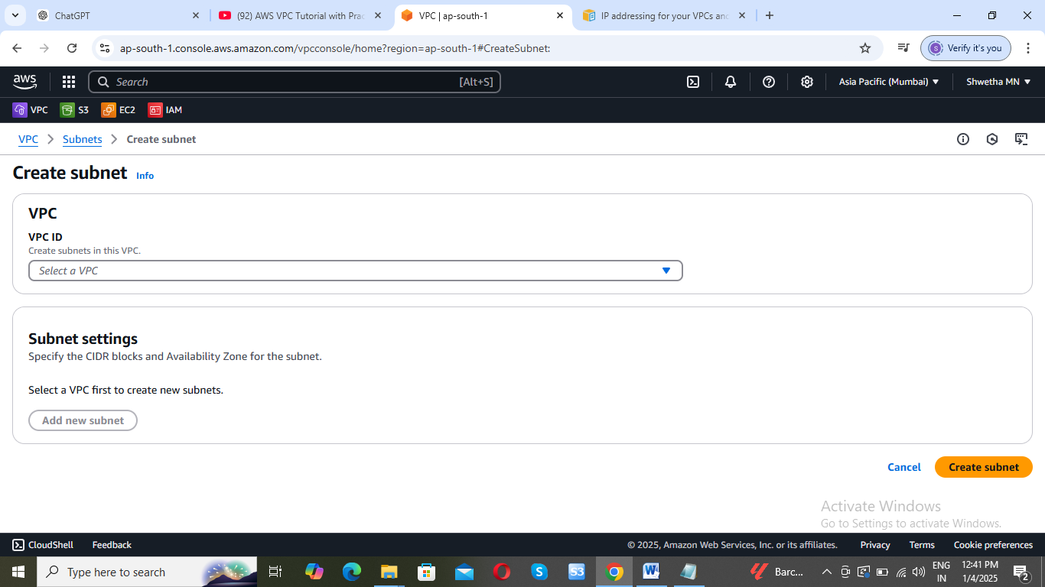

* 1. Select your VPC and specify:

**Subnet Name**: Give a name to the subne

**Availability Zone**: Choose an availability zone within your region.

**CIDR Block**: Specify the range of IP addresses for your subnet. You might use something like 192.168.0.0/25 for your first subnet.

**Public subnet**:

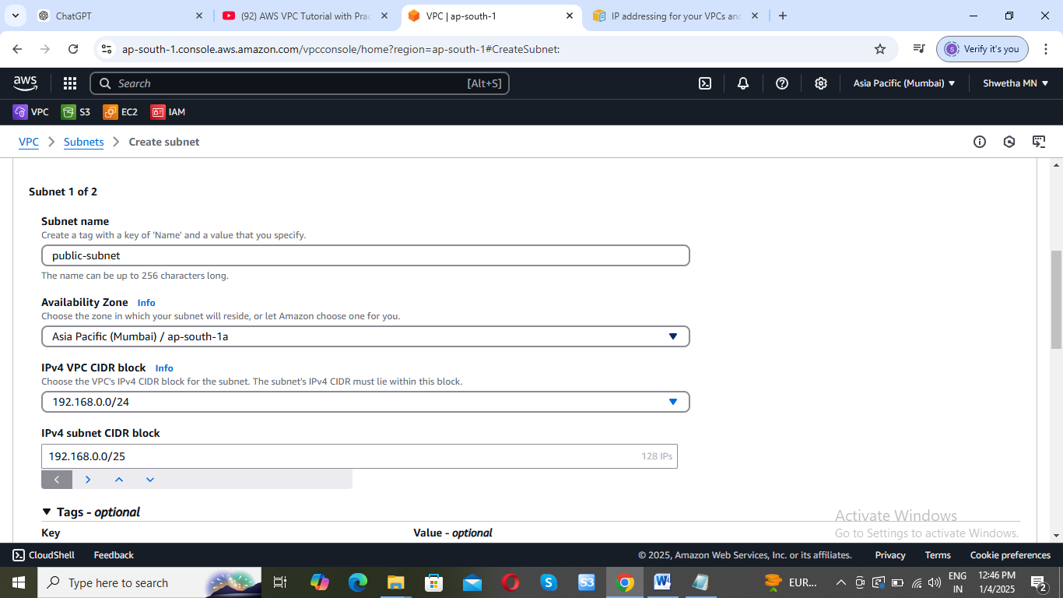

**Private subnet:**

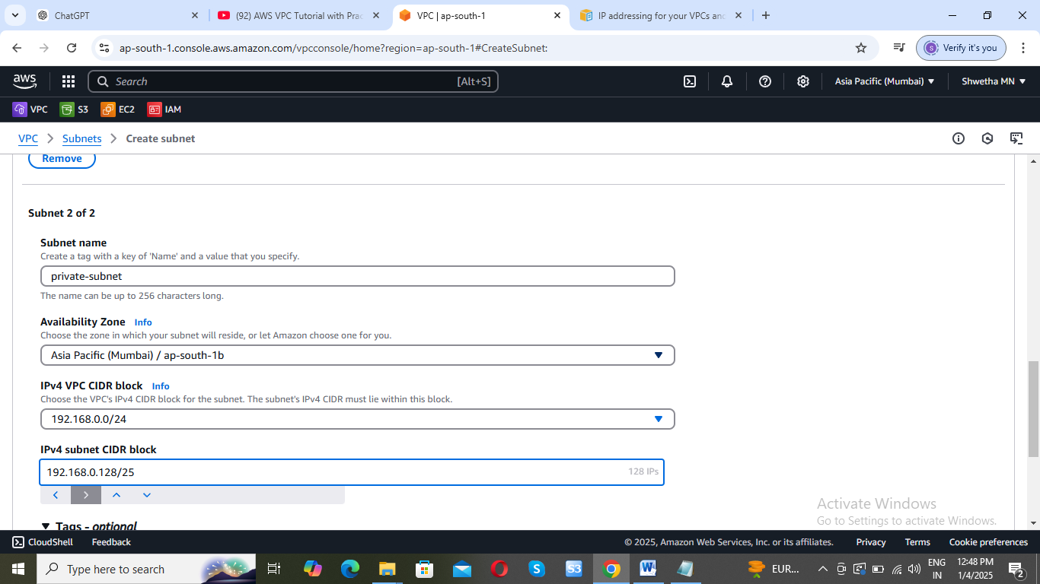

* 1. Click **Create**.

You can create multiple subnets for different purposes (e.g., public, private, or for different availability zones).

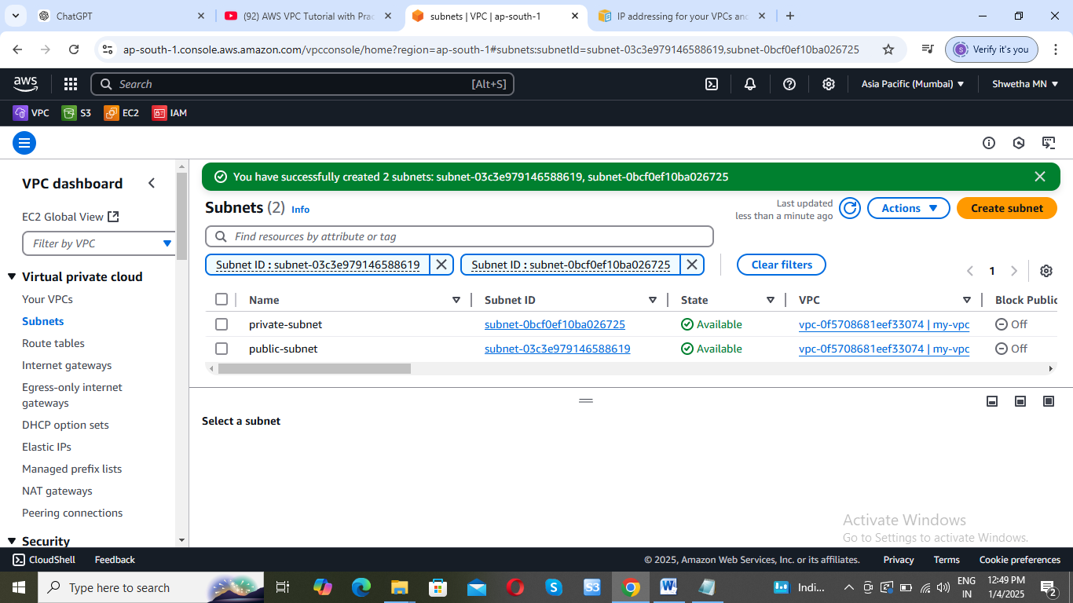

**Step 6: Create Route Tables**

A route table controls the routing for traffic within your VPC. You need to associate it with your subnets

* 1. In the left sidebar, click **Route Tables**.

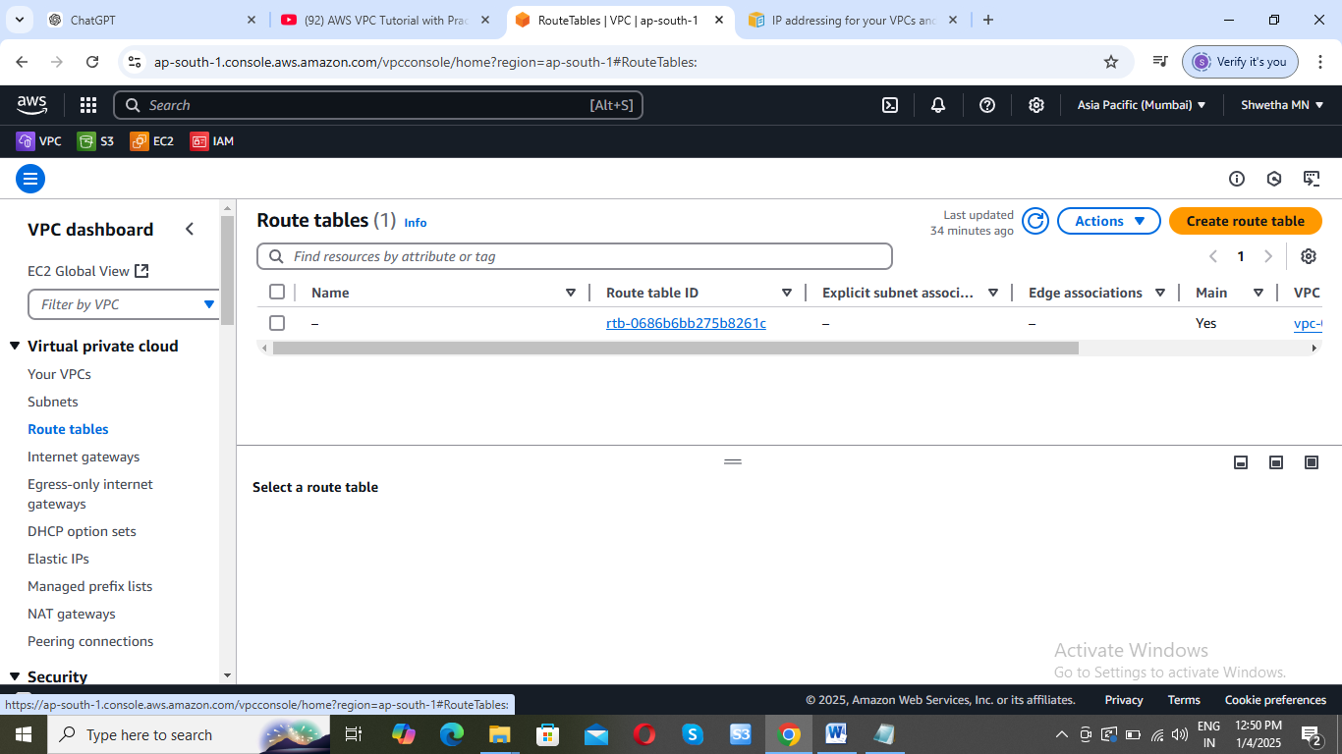

* 1. Click **Create route table** and give it a name.

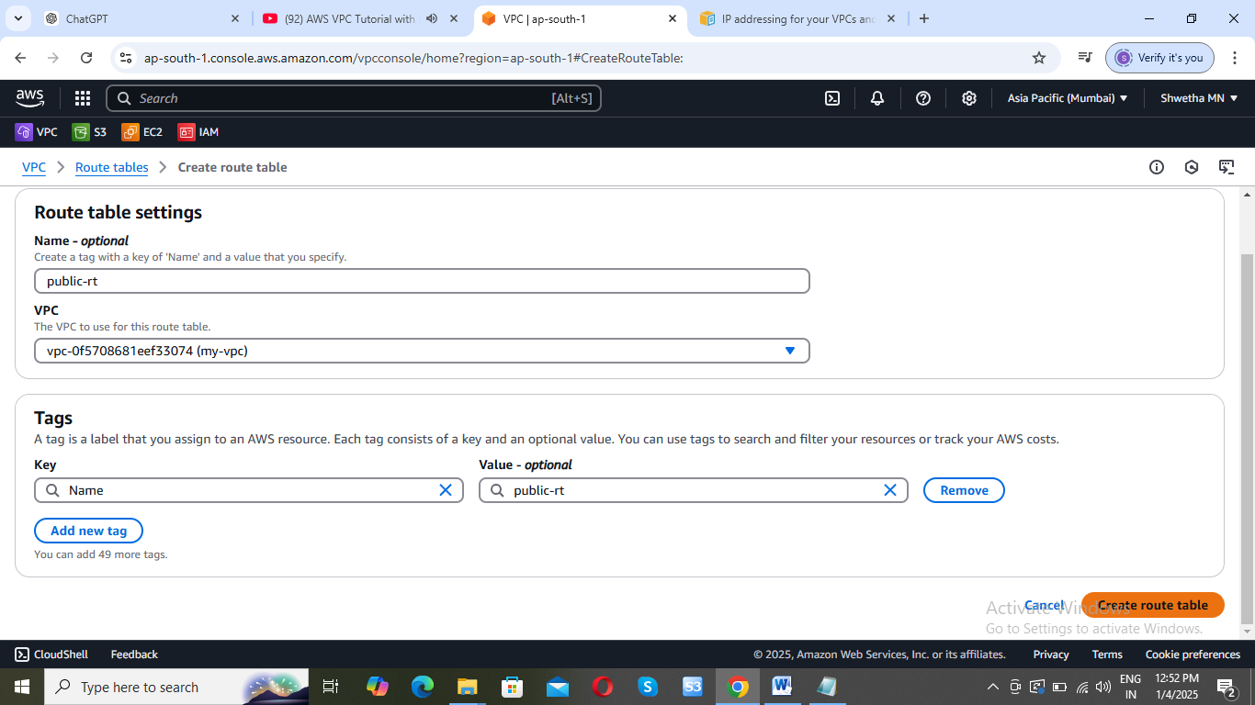

* 1. Once created associated with subnets. In **Subnet Associations** tab, click **Edit subnet associations**, and select the subnet that you want to route internet traffic through (typically the public subnet).

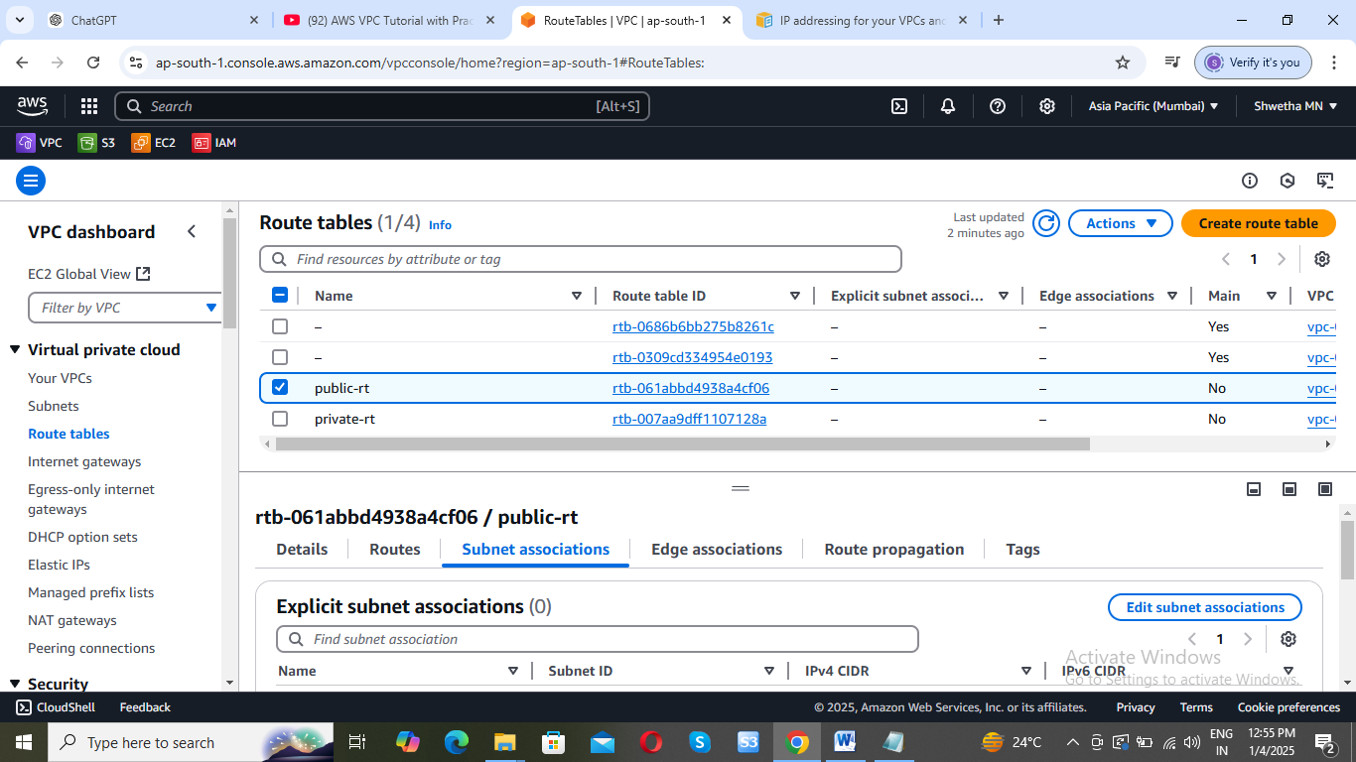

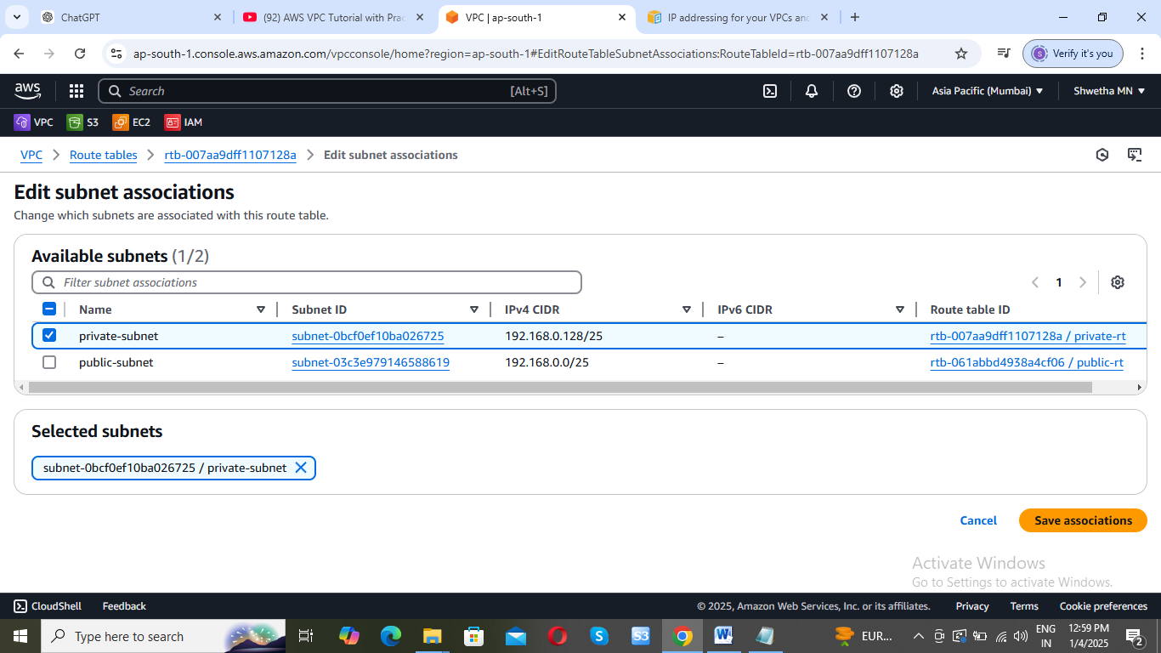

**Public-rt associate with public subnet**

**Private-rt associated with private subnet**

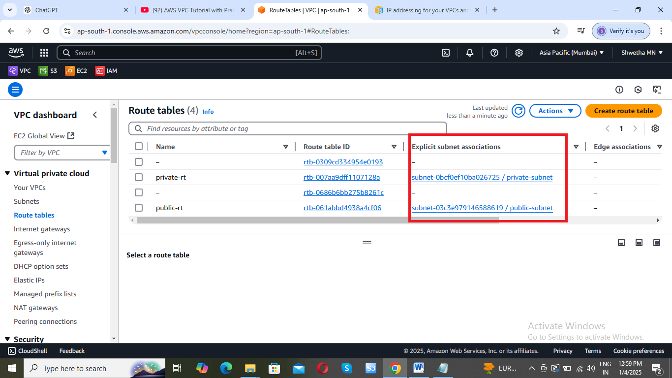

* 1. Once created, select the route table, go to the **Routes** tab, and add a new route to allow internet access:
* Destination: 0.0.0.0/0 (for all IPs)
* Target: Select your Internet Gateway.

